**Name: Vigneshwaarar CR**

**AWID: A20392185**

**Tableau Visualizations:**

1. **Regression Model for Profit:**

In this visualization we are building regression models for each Region’s Profit amount.

The independent variable we considered here is sales amount.

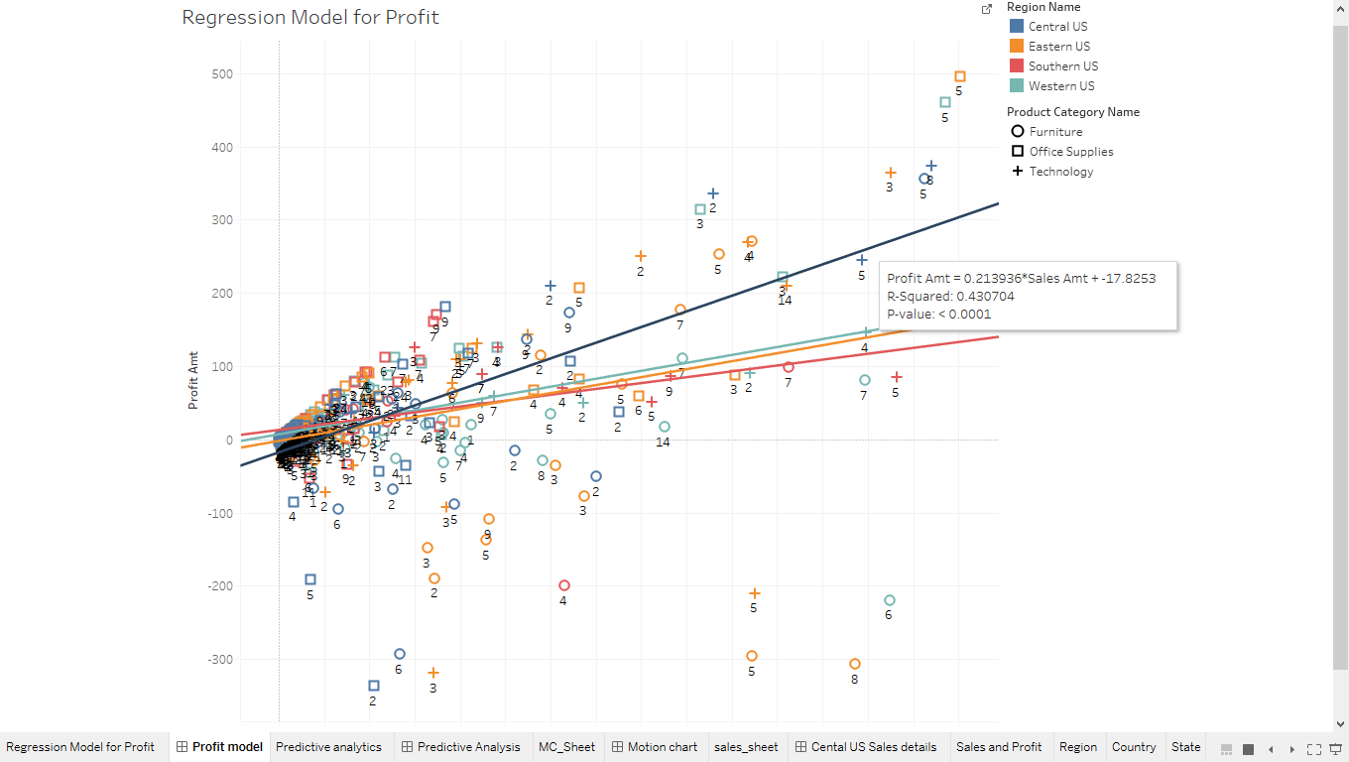

As we see in the above screen shot we could see the tooltip with the regression model, Adj-R2 value and p-value for the model

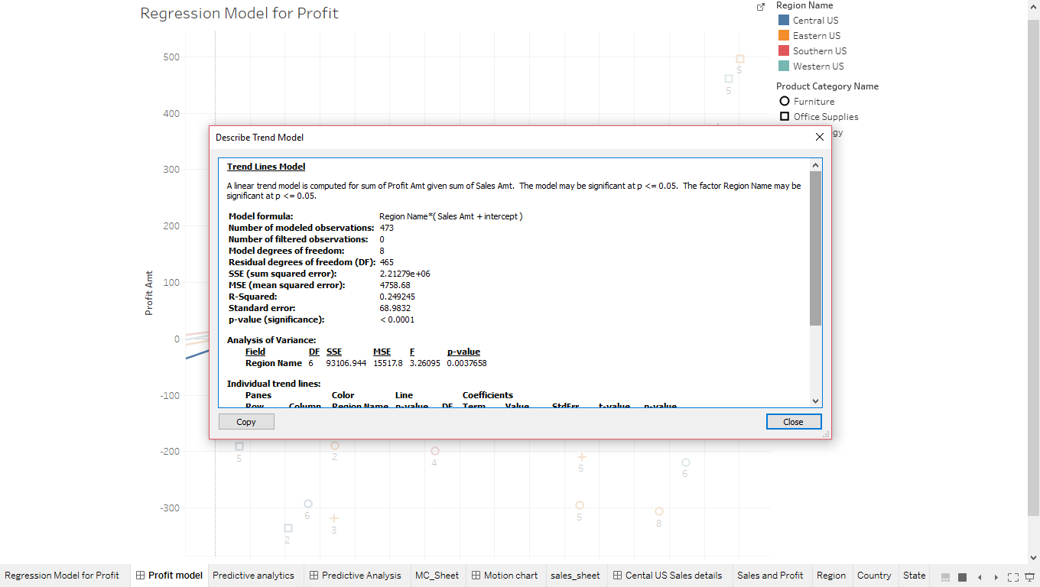

We could also see the specific Region’s model details by right clicking on the trend line and then selecting “describe trend model” option.

1. **Predictive analysis:**

In this visualization we are forecasting the sales amount for the upcoming years

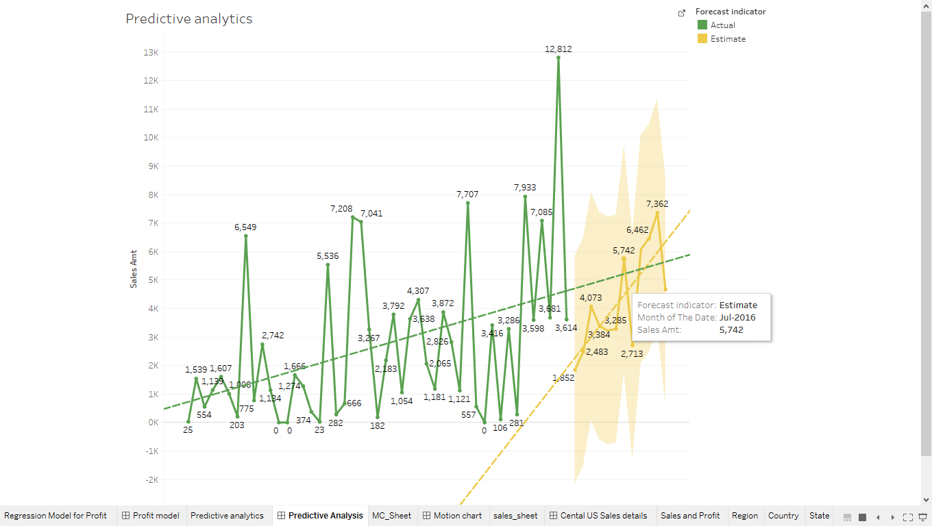

We not only forecast but we can also build the model which can predict the sales amount based on month of the year.

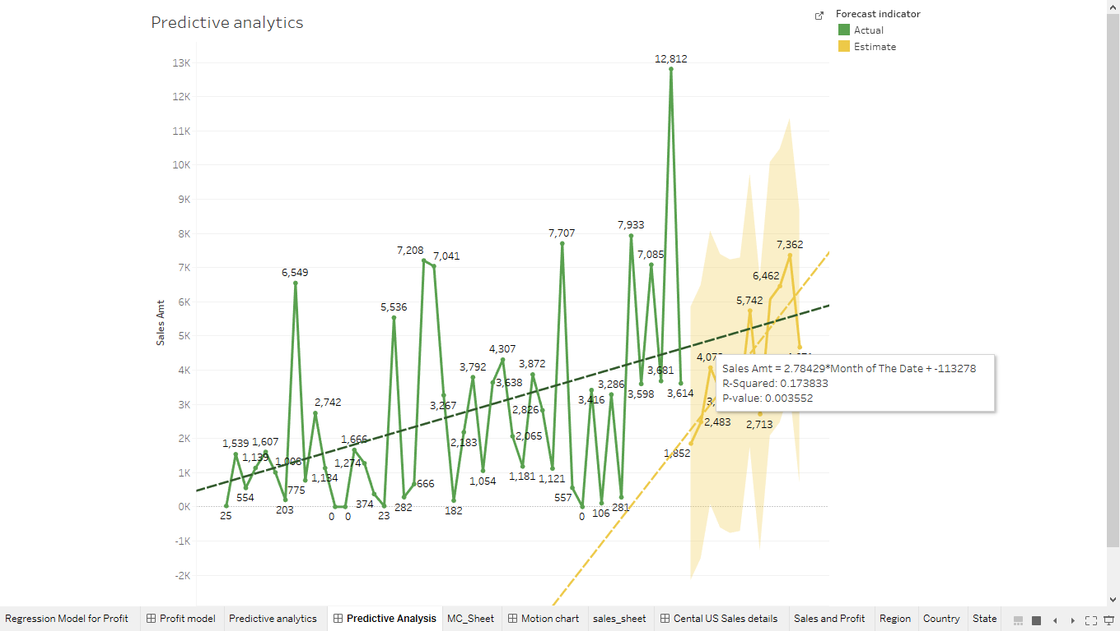

1. **Motion chart:**

In this visualization we are showing how we can build a motion chart which can show our sales amount for each year.

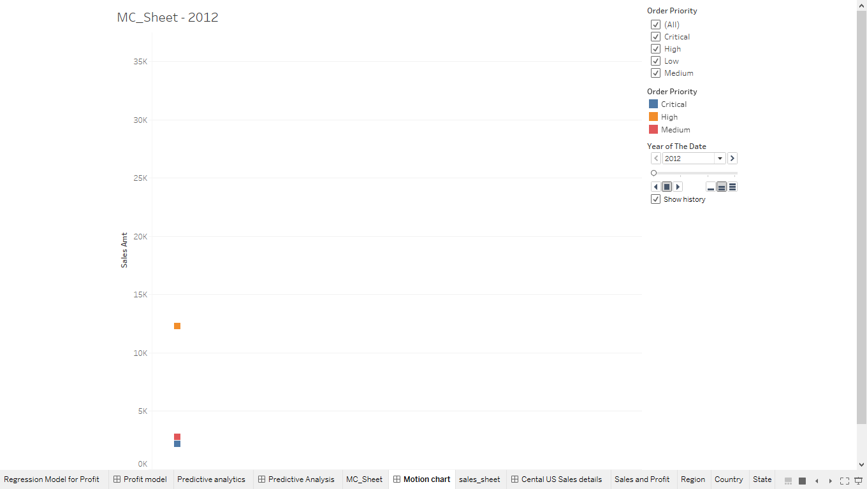

The above screen shot shows the initial stage of the chart and when we click on the play button on the right side of the screen, the motion chart runs, and the trend changes as shown in the screen shot below.

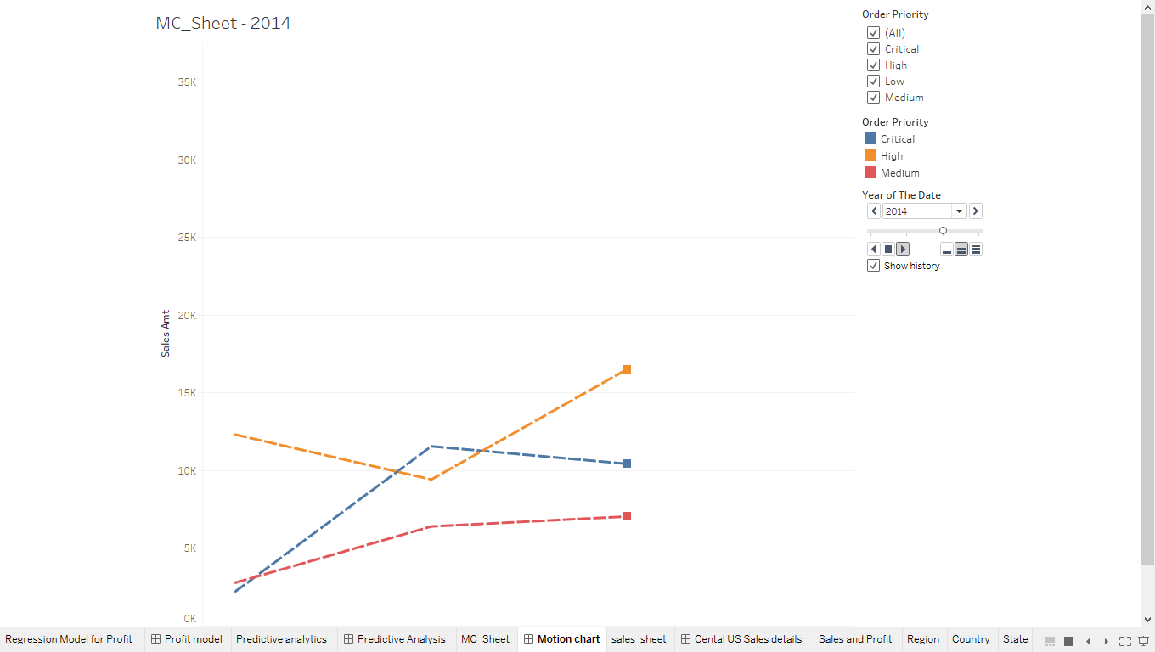

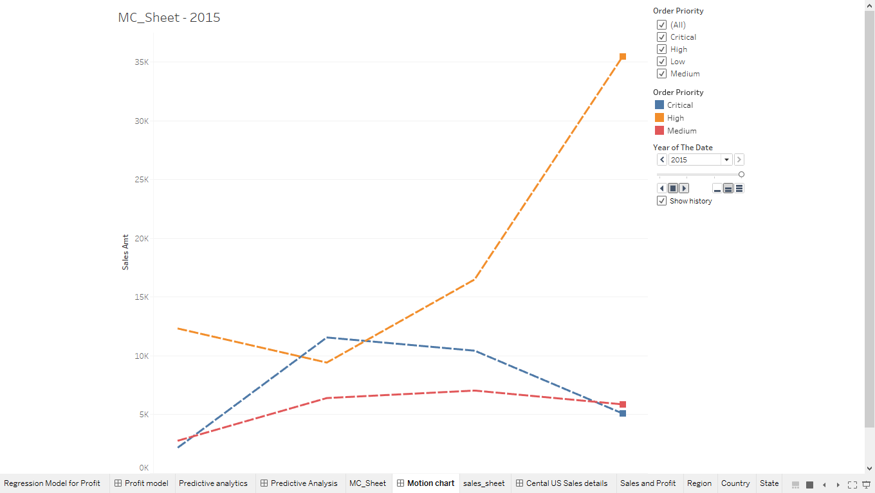

1. **Various geography filters:**

As we see in the below screen shot, we can create filters manually.

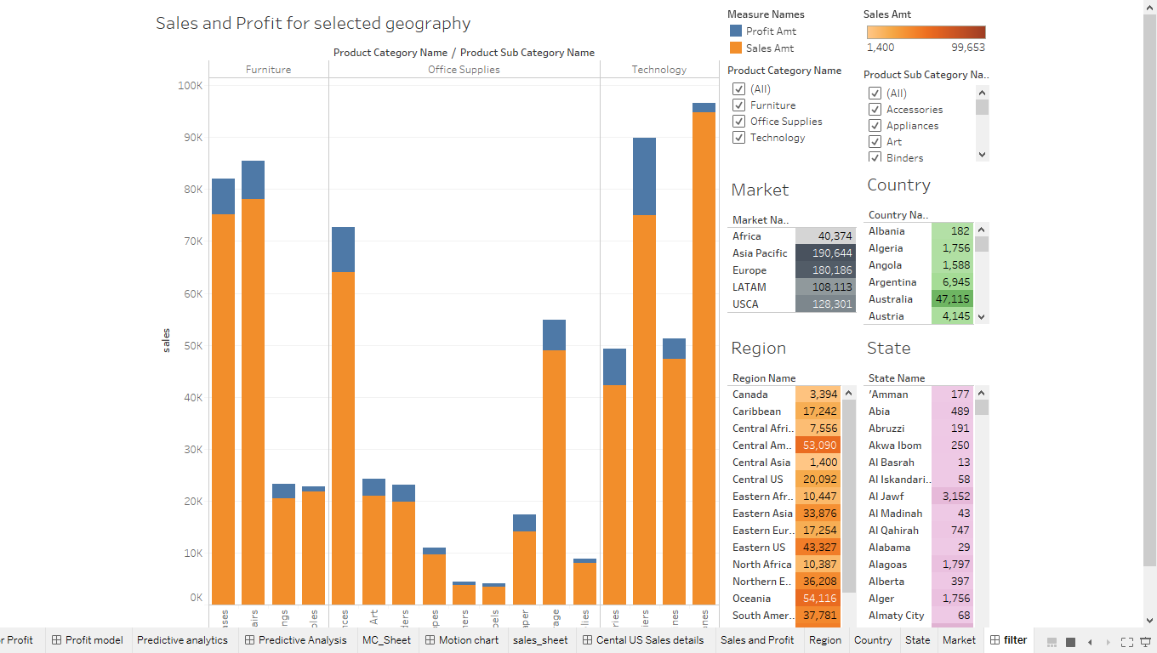

Initially, we need to create a worksheet which can have a specific geography, sales and profit details.

Create another worksheet with can explain sales details for specific product category and sub-category. We add these worksheets in a dashboard and set the worksheet which had sales information for the specific geography as filter. Now any change we make in the geography reflects in the worksheet which contains sales information for product category and sub-category as shown below.

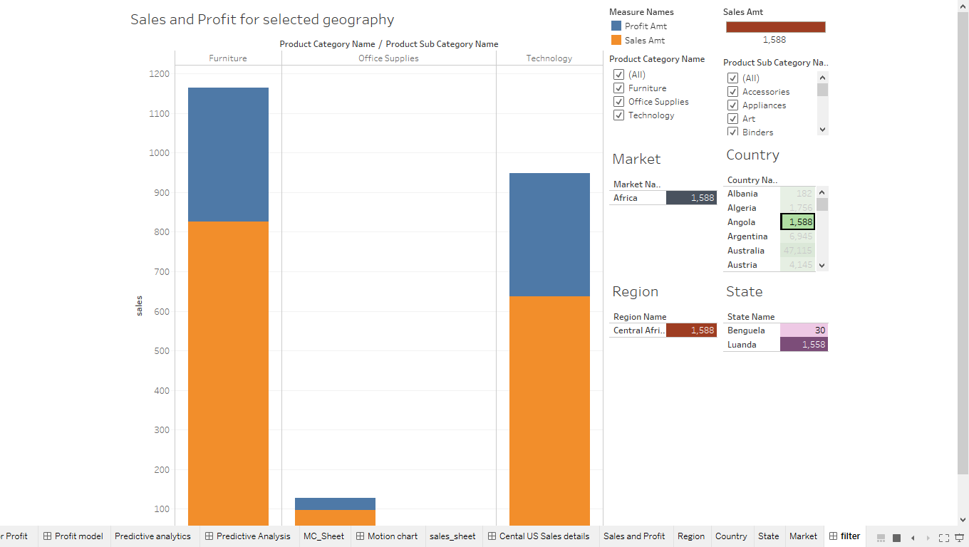

1. **US sales details:**

In this visualization we can visualize the sales information for the specific region

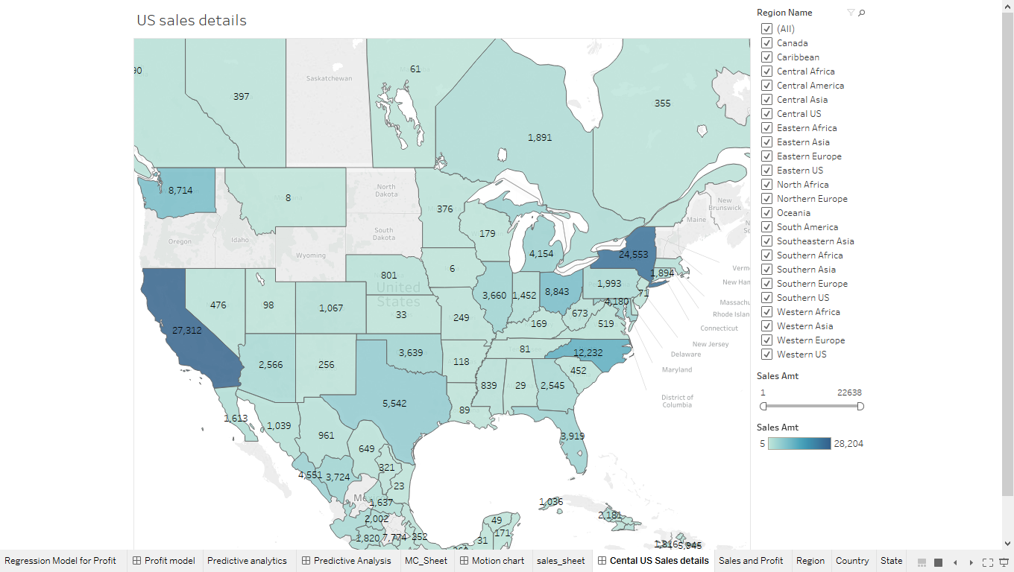

We could see in the above screen shot which illustrates the sales details for each region. any change in filter can show change in sales details for the specific region. below screen shot shows the Central US sales details.

